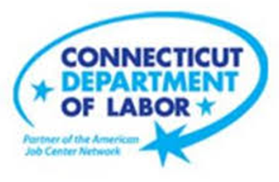

**NEW WEEKLY JOB POSTINGS FROM   
HELP WANTED ONLINE  
Office of Research**

**Week Ending October 22nd, 2022: Overall New Ad Drop of 595 Driven by Health Care.**WETHERSFIELD, October 28th, 2022 – During the week ending October 22nd, there were 7,287 new postings, down 595 new ads or -8% over the week. 8 industries had over the week increases and 13 had decreases. Professional, Scientific, and Technical Services had the largest increase, up 90 new ads (+7%) and Health Care & Social Assistance had the largest decrease, down -552 (-28%). Most of the Pro., Sci., & Tech. Services Increase occurred at KPMG (+30 new ads over the week) and the largest decline within Health Care occurred at the Saint Francis Health System (-236 new ads over the week). The graph below illustrates the 8% statewide decline and corresponding -1% US level shift. Note: The Help Wanted Online data series was revised last month to better reflect job posting behavior on some of its source job board websites. This revision resulted in lower total counts for May-August 2022.  
  
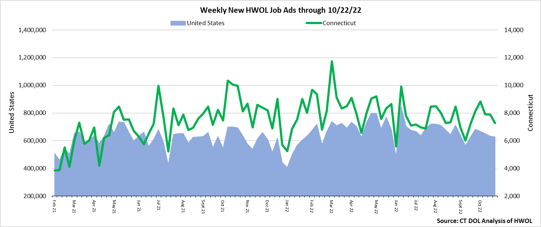  
**Industries** with the most new postings include Health Care & Social Assistance, Finance & Insurance, and Retail Trade.

**Occupations** with the most new postings include Registered Nurses, Retail Salespersons, and Medical & Health Services Managers.

**Employers** with the most new postings include Yale-New Haven Health System, Community Health Center, Inc., Cigna Corporation.

**The three industries with the most new job postings were:**

* **Health Care & Social Assistance** (1,420 new postings, -28% over the week)
* **Finance & Insurance** (757 new postings, +6% over the week)
* **Retail Trade** (747 new postings, -1% over the week)

  
 During the week ending October 22nd, 2022, the -8% new ad total decrease is the net result of increases in 8 industries and declines in 13. The 8 increasing industries grew by a combined 335 new ads and most of that increase occurred in Professional, Scientific, & Technical Services (+57 new ads). The decreasing industries fell by a combined 930 new ads with most of that occurring in Health Care & Social Assistance (-552 new ads). Over four weeks, new ads were up 8% or up 512 new ads. 11 industries were up and 10 decreased. The largest four week increase occurred in Health Care and Social Assistance (+345 new ads) and the largest decrease occurred in Real Estate (-91 new ads).  
  
  
 For more information on total job ads by industry for Connecticut and its labor market areas, see the monthly report available here: <https://www1.ctdol.state.ct.us/lmi/hwol.asp>

**New Job Postings by Occupation** 

**The occupations with the most new postings were:**

* Registered Nurses (317 new postings, -48% over the week)
* Retail Salespersons (227 new postings, -13% over the week)
* Medical & Health Service Managers (168 new postings, +9% over the week)

**Employers with the Most New Job Postings**  Employers with the most new job postings during the week were mostly in Healthcare & Social Assistance, Retail Trade, and Finance & Insurance. The 25 employers shown above account for 20 percent of all new ads. 18 of 25 employers in the top 25 had over-the-week increases, one was unchanged, and 6 had decreases. The top 25 employers with the largest over the week increase and decreases were Community Health Center, Inc. (+135 new ads) and Hartford Healthcare (-152 new ads) respectively.   
  
**What is HWOL?**The **Conference Board Help Wanted Online**® Data Series (HWOL) measures the number of new, first-time Online job postings and jobs reposted from the previous month for over 16,000 Internet job boards, corporate boards, and smaller job sites that serve niche markets and smaller geographic areas. To view more HWOL data, go to: <https://www1.ctdol.state.ct.us/lmi/hwol.asp>